May 8, 2013 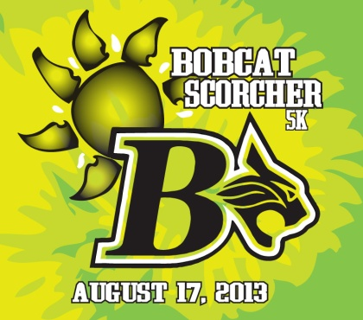

RE: Event Sponsor - 2013 Bobcat Scorcher 5K

Dear PROSPECTIVE SPONSOR,

As you are aware, the sport of running is growing rapidly within our community. This is also true with the high school cross country team. For the past two (2) years, the BHS Cross Country Team has hosted a 5K Race as their season-opener and major fundraiser. Last year’s race had over 400 participants and we hope to top it with 500 this year. Many of the HS teams from Hilton Head, and Beaufort attend to compete for the HS Team Challenge scored within the race. It is quickly becoming a great community event. The 3rd Annual Bobcat Scorcher’s date has been set for Saturday, August 17th and once again will be held in the scenic community of Hampton Hall.

Bluffton High School Cross Country Team is seeking an event sponsor for this year’s race. We would be honored if you were to consider being this sponsor.

The team will take a picture in the shirts and frame it for your office. You or someone from your office may contact either Coach Dana House (843) 815-5925 or Rob Fyfe (843)815-1718. Please review the Sponsorship package let us know of your decision.

Thank you for your consideration. We appreciate your support. GO BOBCATS!

Sincerely,
The Bluffton HS Cross Country Team

2013 Bluffton High School
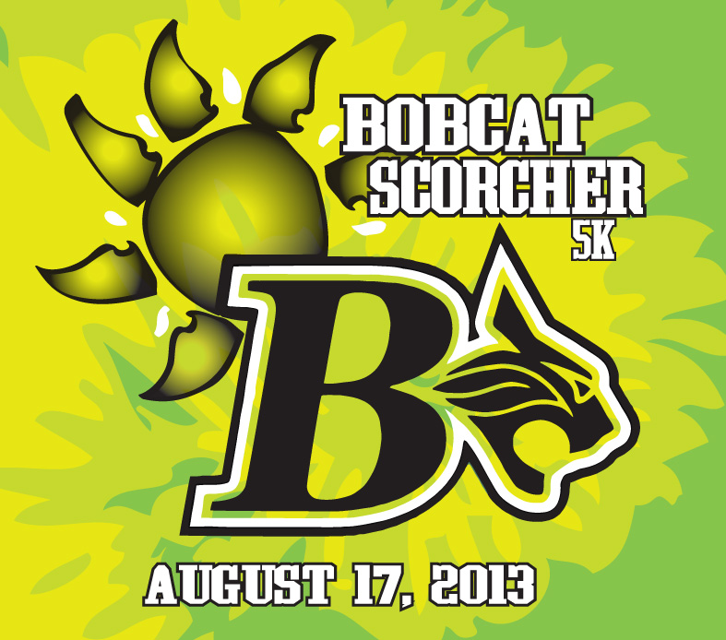
5K Run/Walk
August 17th, 2013
Hampton Hall, Bluffton, SC
Sponsorship Proposal

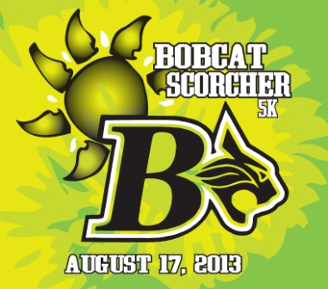

2013 Bluffton High School/Bobcat Scorcher 5K Sponsorship Program:
We are thrilled to announce the 2013 Bluffton High School Bobcat Scorcher 5K Run/Walk. The Race will be attracting both the serious competitive racer and the occasional runner/walker to Hampton Hall in Bluffton on August 17th to raise money for the Bluffton Cross Country team. The race starts and finishes at the beautiful Hampton Hall Club in Bluffton, SC at 8 AM on August 17, 2013. Runners will enjoy the scenery while racing on a flat and fast all road course within the Hampton Hall Community.
Thank you for your consideration of sponsorship.
Event Description

Event Name: Bobcat Scorcher 5K
Location: Hampton Hall. Bluffton, SC
Date: 8:00 AM, Saturday - August 17th, 2013
Main Events: 5K Run/Walk. Featuring the High School Team 5K Challenge
Other Activities: Music, sponsor tables for food, drink, sports gear, local business
Age group awards ceremony. This event is chip timed by
Palmetto Running Company. www.palmettorunningco.com

Purpose: To help raise money for the Bluffton High School Track and Cross country teams.

T-Shirts: Our famous Tie-Dye Race shirts given to all participants.

Race Packets: All entrants receive a race packet that will be filled with Sponsor information
and cool SWAG

Sponsorship Levels & Pricing

Title Sponsor - $1,250
• Sponsorship name on all promotional materials, including Premium front location on
Participant t-shirts and posters
•We will provide a printed logo banner to be displayed at the finish line
• Company flyer/brochure/coupon in the Palmetto Running Co Race Bag
• Post-race table for product/service promotion and sample give away
• Exposure in all Print & Radio advertising, Palmetto Running Co web site, email blasts
Facebook and Active.com
• Company name and logo on entry forms (3,000 distributed)
• 5 complimentary race entries
• 5 complimentary T- shirts

Bobcat - $500
• Sponsorship name on all promotional materials, including level one back location on
Participant t-shirts.
• Company flyer/brochure/coupon in the Palmetto Running Co Race Bag
• Post-race table for product/service promotion and sample give away
• Exposure in all Print advertising, Palmetto Running Co web site, email blasts and facebook
• Company name and logo on entry forms (3,000 distributed)
• 3 complimentary race entries
• 3 complimentary T- shirts

Lynx - $250
• Sponsorship name on all promotional materials, including level two back location on
Participant t-shirts.
• Company flyer/brochure/coupon in the Palmetto Running Co Race Bag
• Post-race table for product/service promotion and sample give away
• Company name and logo on entry forms (3,000 distributed)
• 1 complimentary race entry
• 1 complimentary T- shirt

Please make sponsorship checks payable to Bluffton High School
and note Bobcat Scorcher Sponsor in the memo line.

Thanks for supporting Bluffton High School’s Cross Country & Track Programs!

